Client Name:
Julia Herrera
Client Address:
441 Silkwood Drive, Bryan, 77803
Phone Number:
979-213-8125

Distance from the Church:
3.2 miles - 9 minutes

Description of the work:
Build a 18-foot ramp with porch
Build a back deck 6x8

Site Pictures
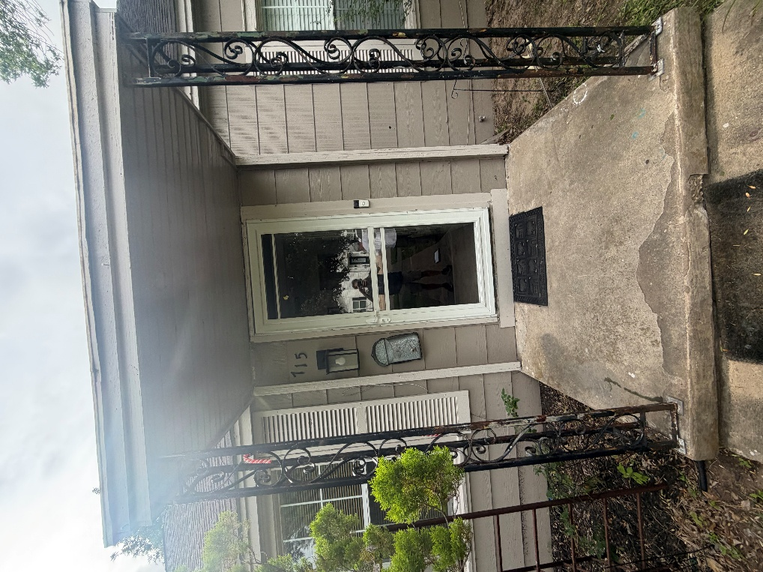
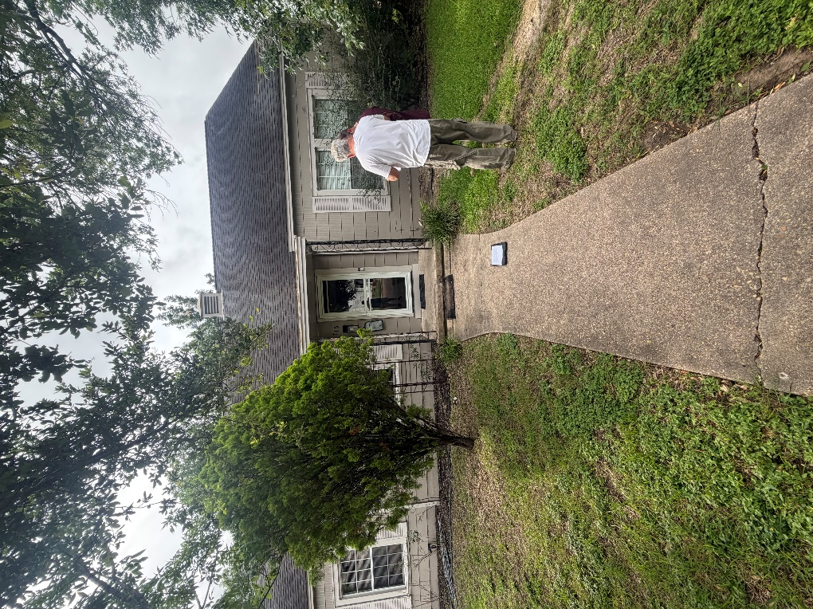
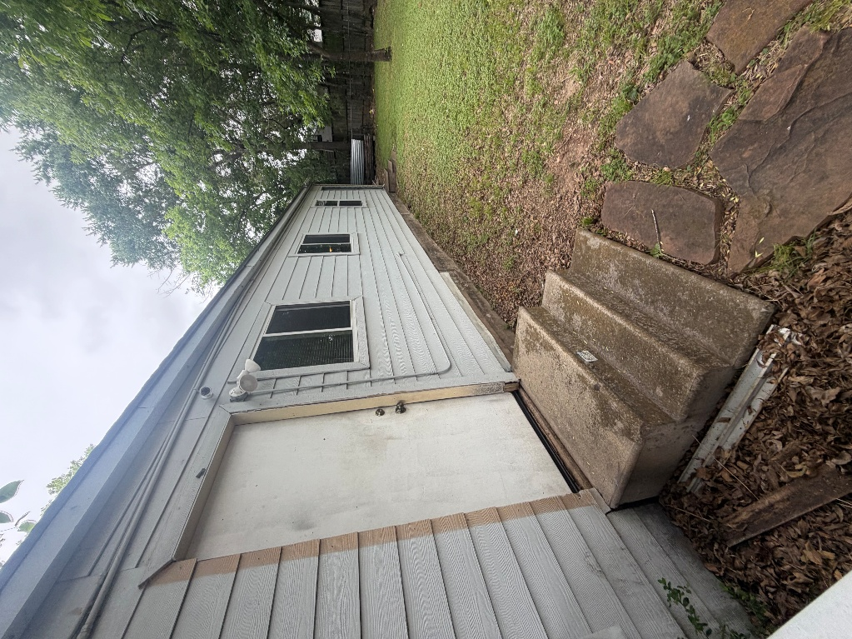
Rendered Project A
“Build to site not to plan”
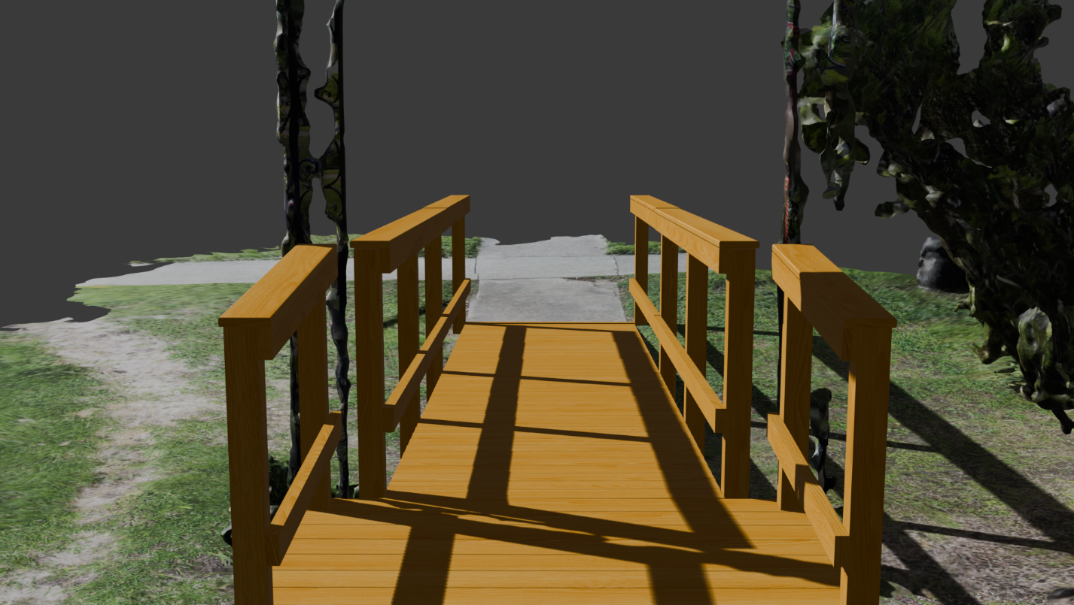
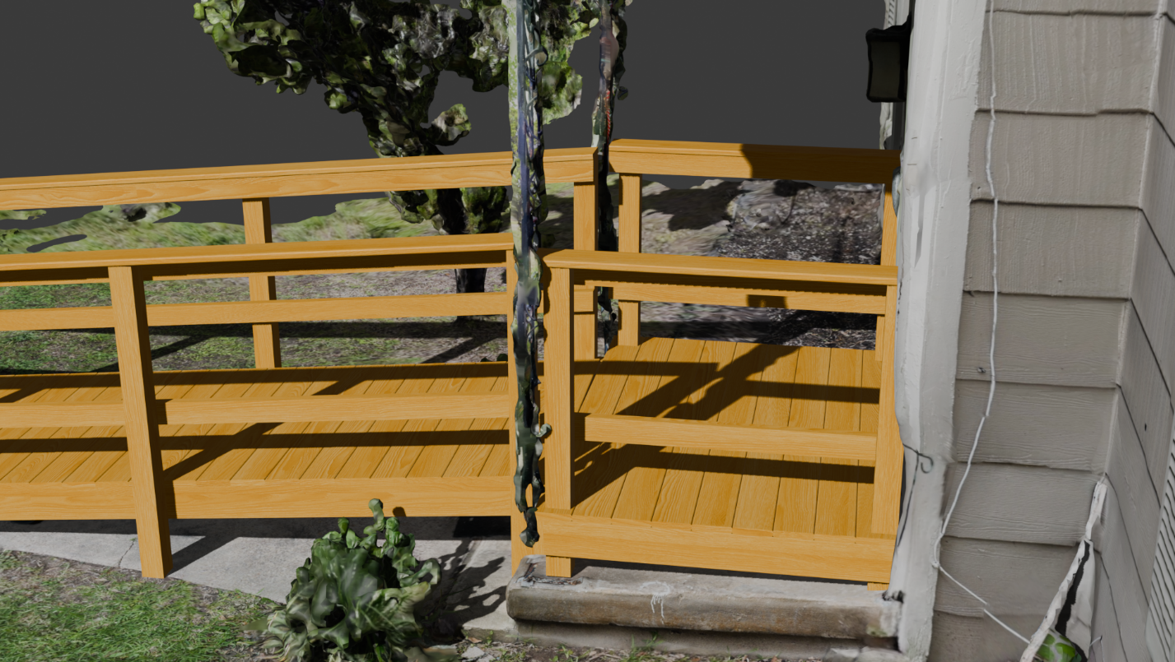
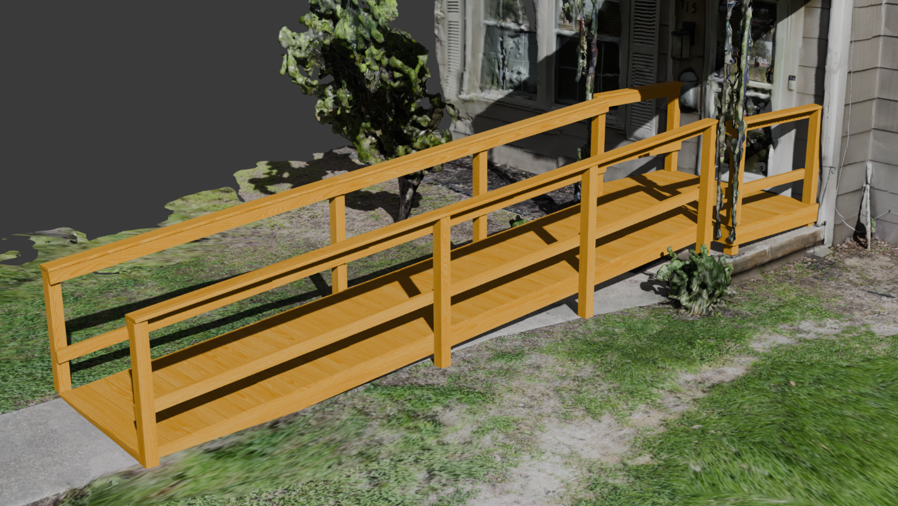
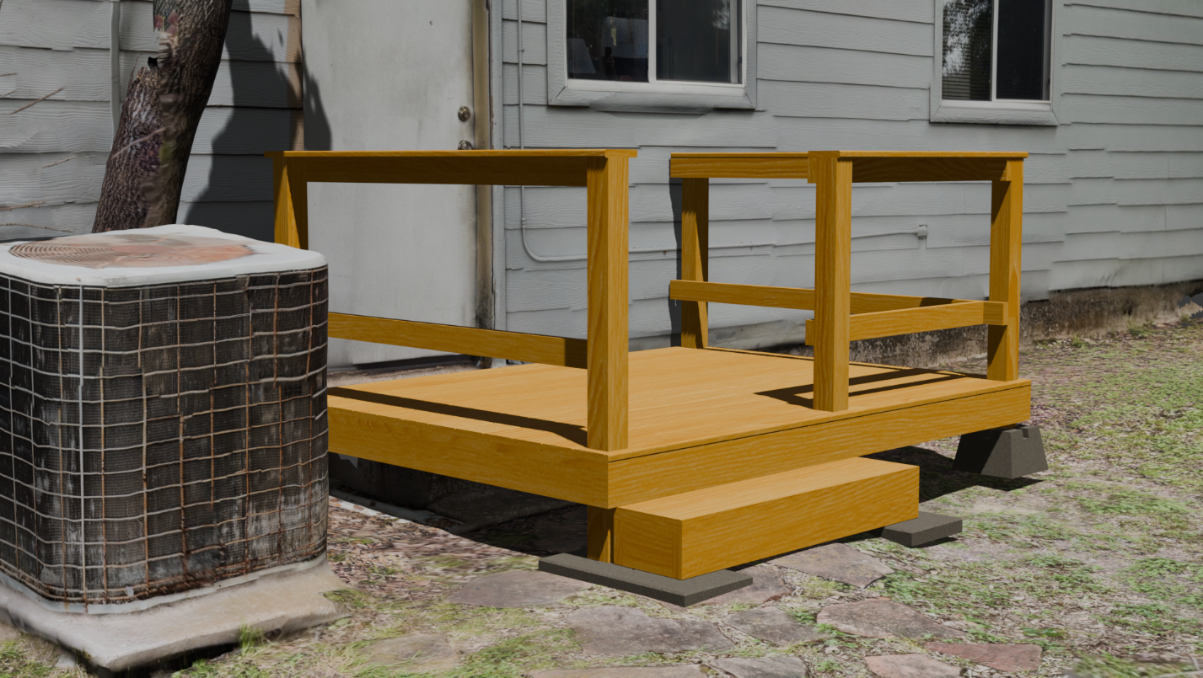
Building Notes
- Ramp
  - Frame is the most difficult part measure it
    - Add extra support to the middle to the ground
  - Calculate the slope of ramp when frame is built
    - Build the full 10ft box first
- Back Deck
  - Big ol concrete steps
    - Need to be remove, possibly broken in place
  - The steps should be in between 6-8 inches in rise
    - The steps should be connected to the deck

